1. 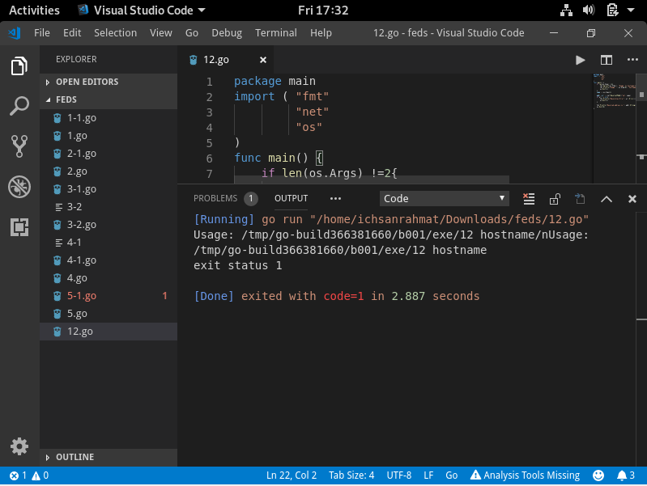

So for the algorithm they check if there’s an input or no, then they have function to receive the input and check the IP address of the input, then they can check whether the input was wrong and they made an output.

1. 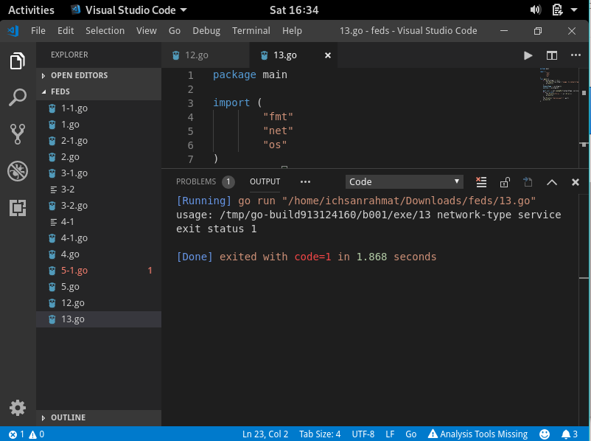

So, for the algorithm they check if there’s an input or no, then they checked network type input and service input, then they search the port form the input and to check whether the input is false or wrong and they meant to output the port.

1. 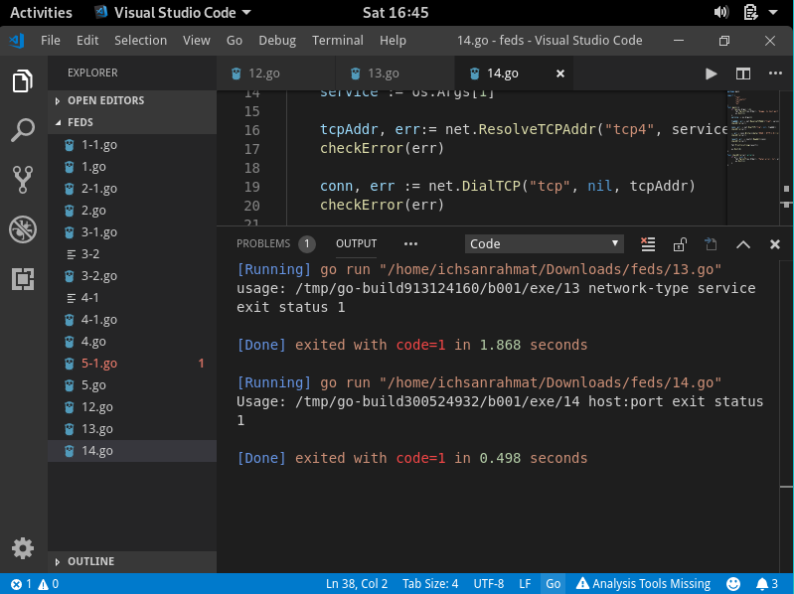

the algorithm do the if to check if there’s no input, then receive and save the input, then they check the tcp address of the input and checked if there’s an error for several times and then they check the connection by dial the tcp address and check the input and save the conn result to output in and the last one is the function to check error.

1. 